Name of Exercise | Threat Assessment Exercise 1
Objective of Exercise | To practice the student in basic application of threat assessment to enable them to be able to interpret a threat assessment and identify potential VAs and VPs.
Situation | Situation.  You are a Search Team Commander working in an Infantry Company as part of the UN Mission in CARANA (UNMIC). Your company was deployed as part of a peacekeeping force to help respond to the instability caused by insurgent groups operating in CARANA seeking to overthrow the legitimate government. Your battalion is located in a Main Operating Base. Your Company in a Forward Operating Base (FOB) near a small village to provide local security.  In addition to normal vehicle patrols, the Company conducts regular foot patrols through the centre of village to reassure the population and deter the insurgent group form gaining popular support.  The patrols tend to take place in the morning before the heat of the day and they always use the route shown either clockwise or anti clockwise, normally stopping for a water break on route. The local population routinely use this same routes in the village area but they do not use the routes near the FOB area.  5 days ago there was an IED attack that hit one of your foot patrols killing one soldier and injuring one other.  From other incidents in the country the insurgents are believed to be capable of making both command IED (command wire only) and victim operated IEDs.
Exercise Requirements | As the Search Team Commander you are to carry out a threat assessment and identify possible VAs and VPs.  Your syndicate must, as a minimum;  • Complete the threat assessment using the 6Ws.  • Specifically identify the VPs and VA’s and be able to qualify them. i.e. explain why they are VA’s and VPs.  • Remember to use CAGES to help identify and qualify VPs and VAs.  - Channeling – are there parts of the route which are channeled with no alternative by-pass?  - Aiming Markers – Are there possible aiming markers or linear features to aim along?  - Ground – Does the ground lend itself to an attack?  - Environment – Is there unusual activity?  - Setting Patterns – Have we set a targetable pattern of behaviour?  You have 20 minutes to carry out the assessment. You are to provide a 5-minute brief to the class on your assessment and recommendations.  IF YOU HAVE ANY QUESTIONS ASK

MAP IN GENERAL
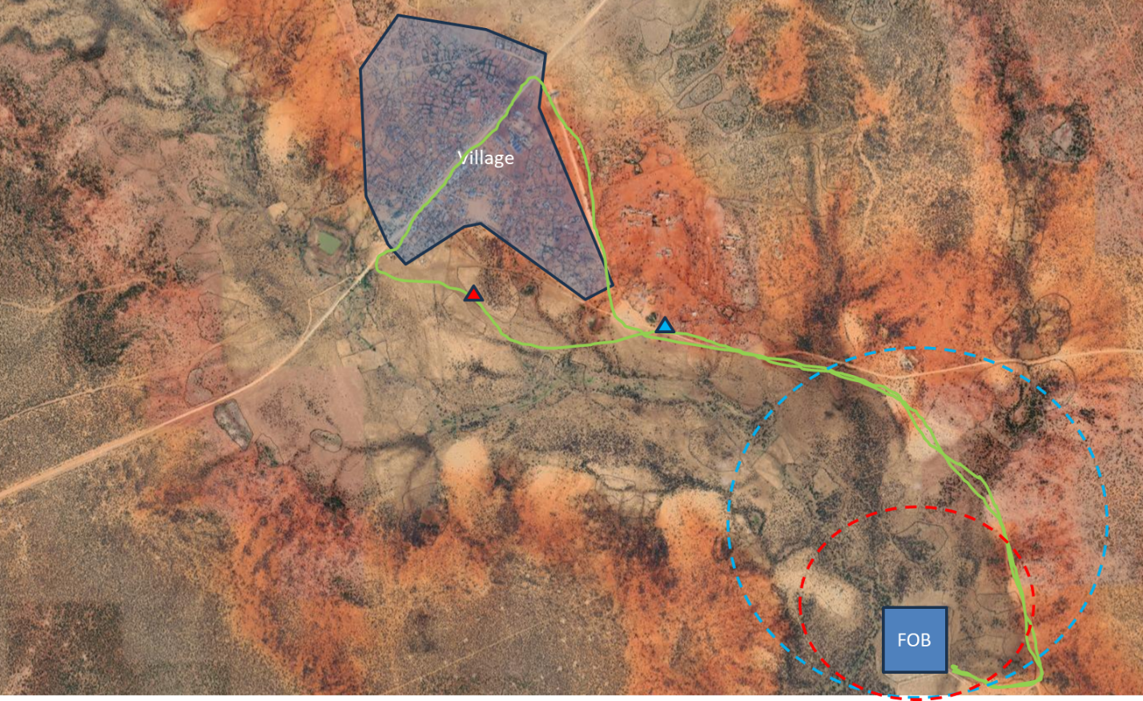
MAP IN DETAIL
MAP IN DETAIL
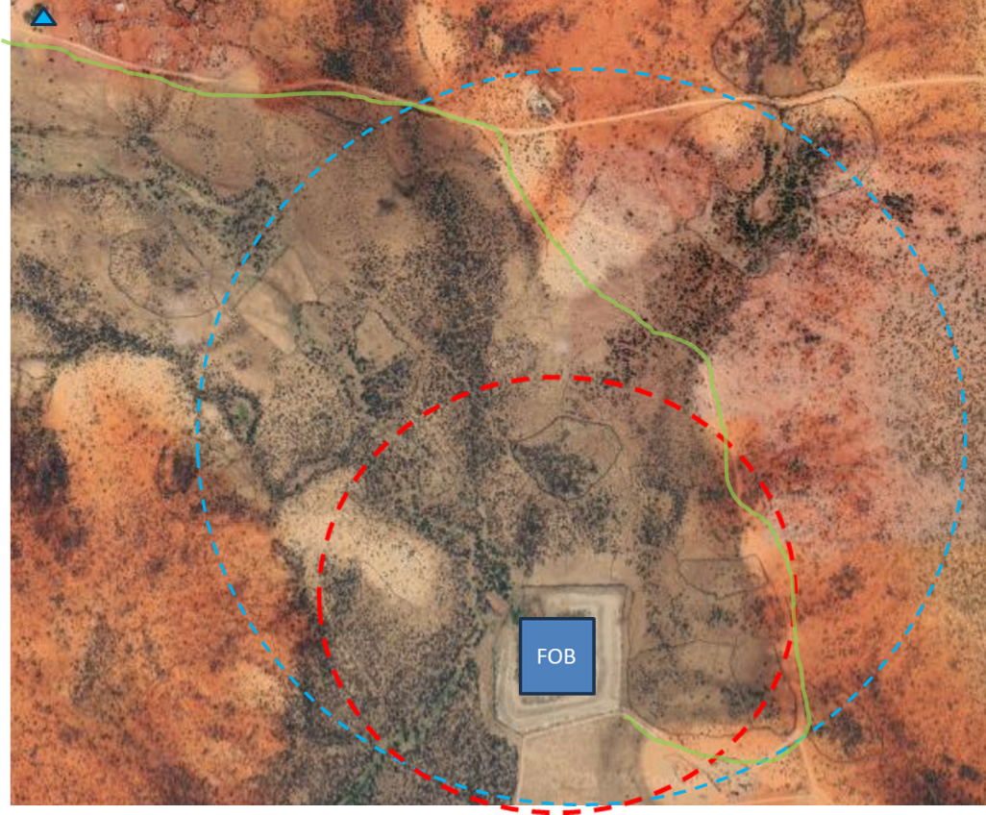
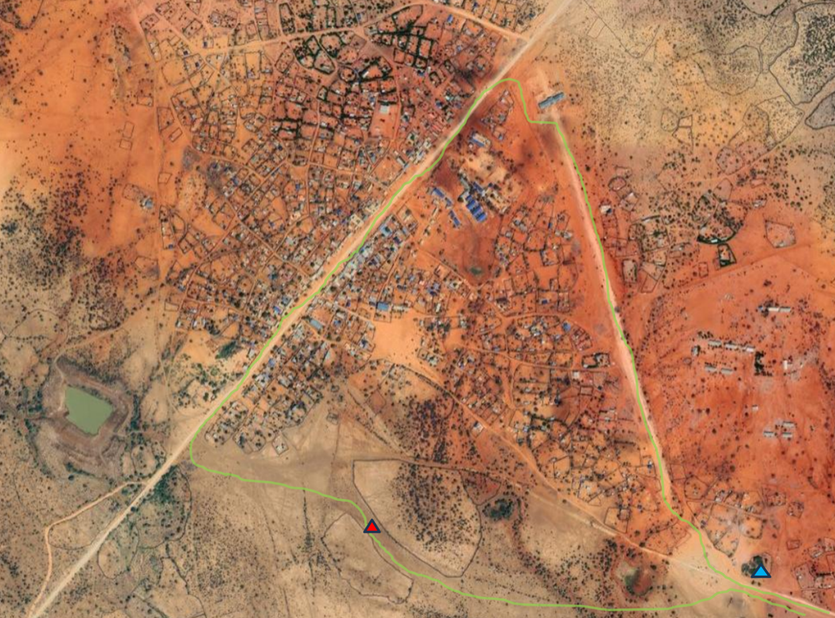
RECENT IED INCIDENTS
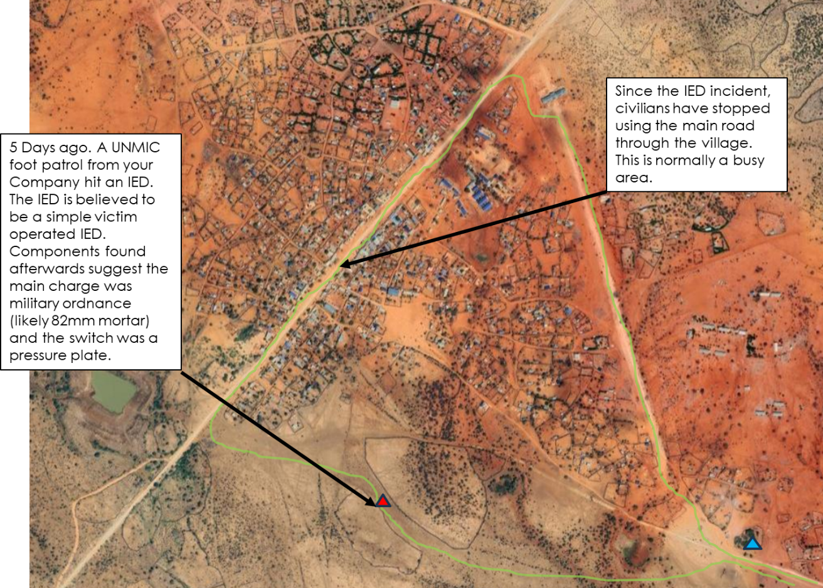

Instructor Guidance – NOT TO BE ISSUED TO STUDENTS
The students should be encouraged to use the 6Ws for completing the threat assessment process:
Intent
Who is the threat from – the students should identify who the threat is from. In this case, it is simply the local insurgent group.
Who is the target – the students should highlight that the insurgent group is specifically targeting the UN foot patrols.
Why – the students should extract from the scenario.
Capability
What – the insurgents have all types of IED but the limited access to resources should steer the students toward the use of Victim Operated or Command Wire Operated IEDs targeting dismounted patrols.
Opportunity.
Where – the student must identify to the likely terrain and situational VPs. These include the channelled areas of the route, the areas where the FOB cannot observe, the situational VP created by the stop off location. The congested urban area could be identified as a VA also. Student should highlight that the observed area by the FOB by night should not be a VA/VP.
When – If the students highlight that there is a situational VP created by the stop off location, they will need to highlight there is a time based threat.

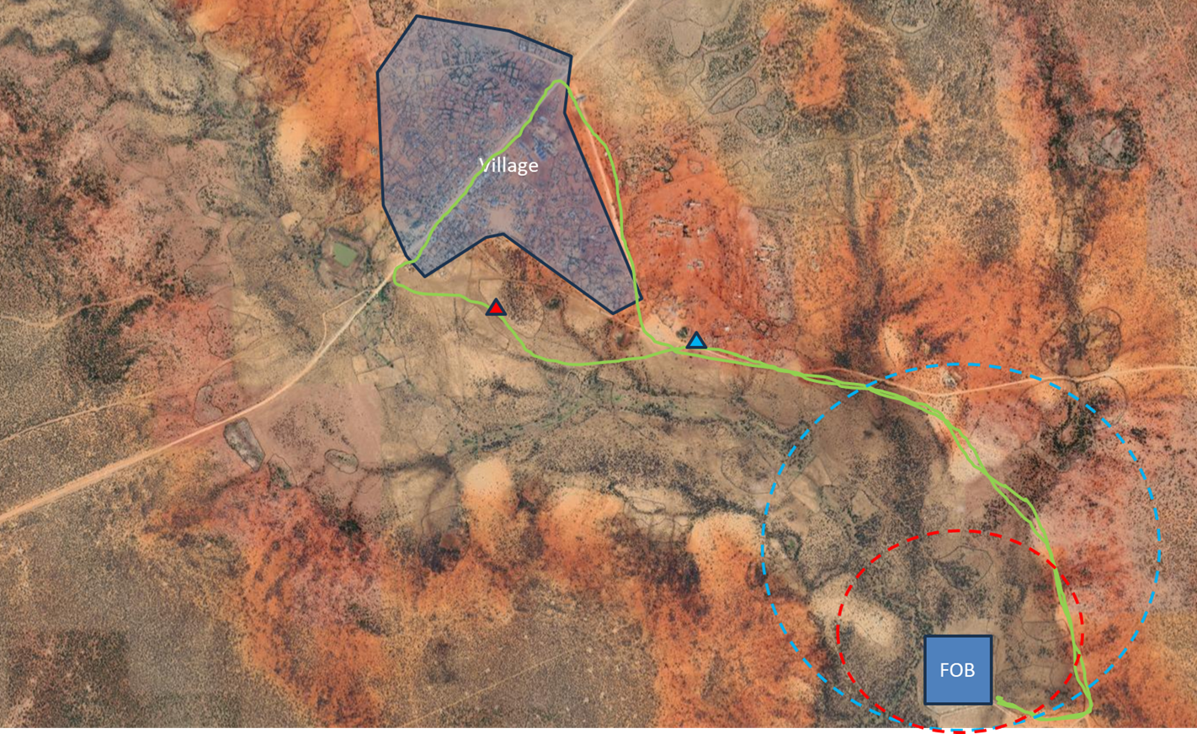
Possible VAs/VPs.
1 – Channelled area. This area is not observed at night.
2 – Situational VP. Setting patterns.
3 – Channelled area.
4 – Channelled area.
5 – VA. Channelled area and environmental factors (unusual civilian activity).
6 – Channelled Area and recent IED location.
7 - Channelled area. This area is not observed at night.
7
6
5
4
3
2
1

Name of Exercise | Threat Assessment Exercise 2
Objective of Exercise | To practice the student in basic application of threat assessment to enable them to be able to interpret a threat assessment and identify potential VAs and VPs.
Situation | Situation.  You are a member of an insurgency group deployed in CARANA. Your organization is part of a wider terrorist group operating in CARANA seeking to overthrow the legitimate government. Your group has been tasked to cause disruption and inflict casualties on UNMIC forces deploying from a nearby Forward Operating Base (FOB) and gain support from the local population.  In addition to normal vehicle patrols, the UNMIC Forces conducts regular foot patrols through the center of the village to reassure the population and deter your insurgent group from gaining popular support.  The patrols tend to take place in the morning before the heat of the day and late in the evening, they always use the route shown either clockwise or anti clockwise, normally stopping for a water break on route, 5 and 25m checks are conducted whenever they stop. The local population routinely use this same routes in the village area but they do not use the routes near the FOB area.  5 days ago you emplaced an VO IED that was found and neutralized by the UNMIC forces.  You are now required to make up for your previous embarrassment and prove to your commanders that you are able to conduct an effective IED attack
Exercise Requirements | As an aggressor you are to carry out a IED attack. You have both command IED (command wire only), victim operated IEDs, and timer devices at your disposal.  Your syndicate must consider:  - What type of means of initiation you will use.  - What type of main charge  - Where will you emplace your device.  - When will you emplace the device.  You have 20 minutes to carry out the assessment. You are to provide a 5-minute brief to the class on your assessment and recommendations.  IF YOU HAVE ANY QUESTIONS ASK

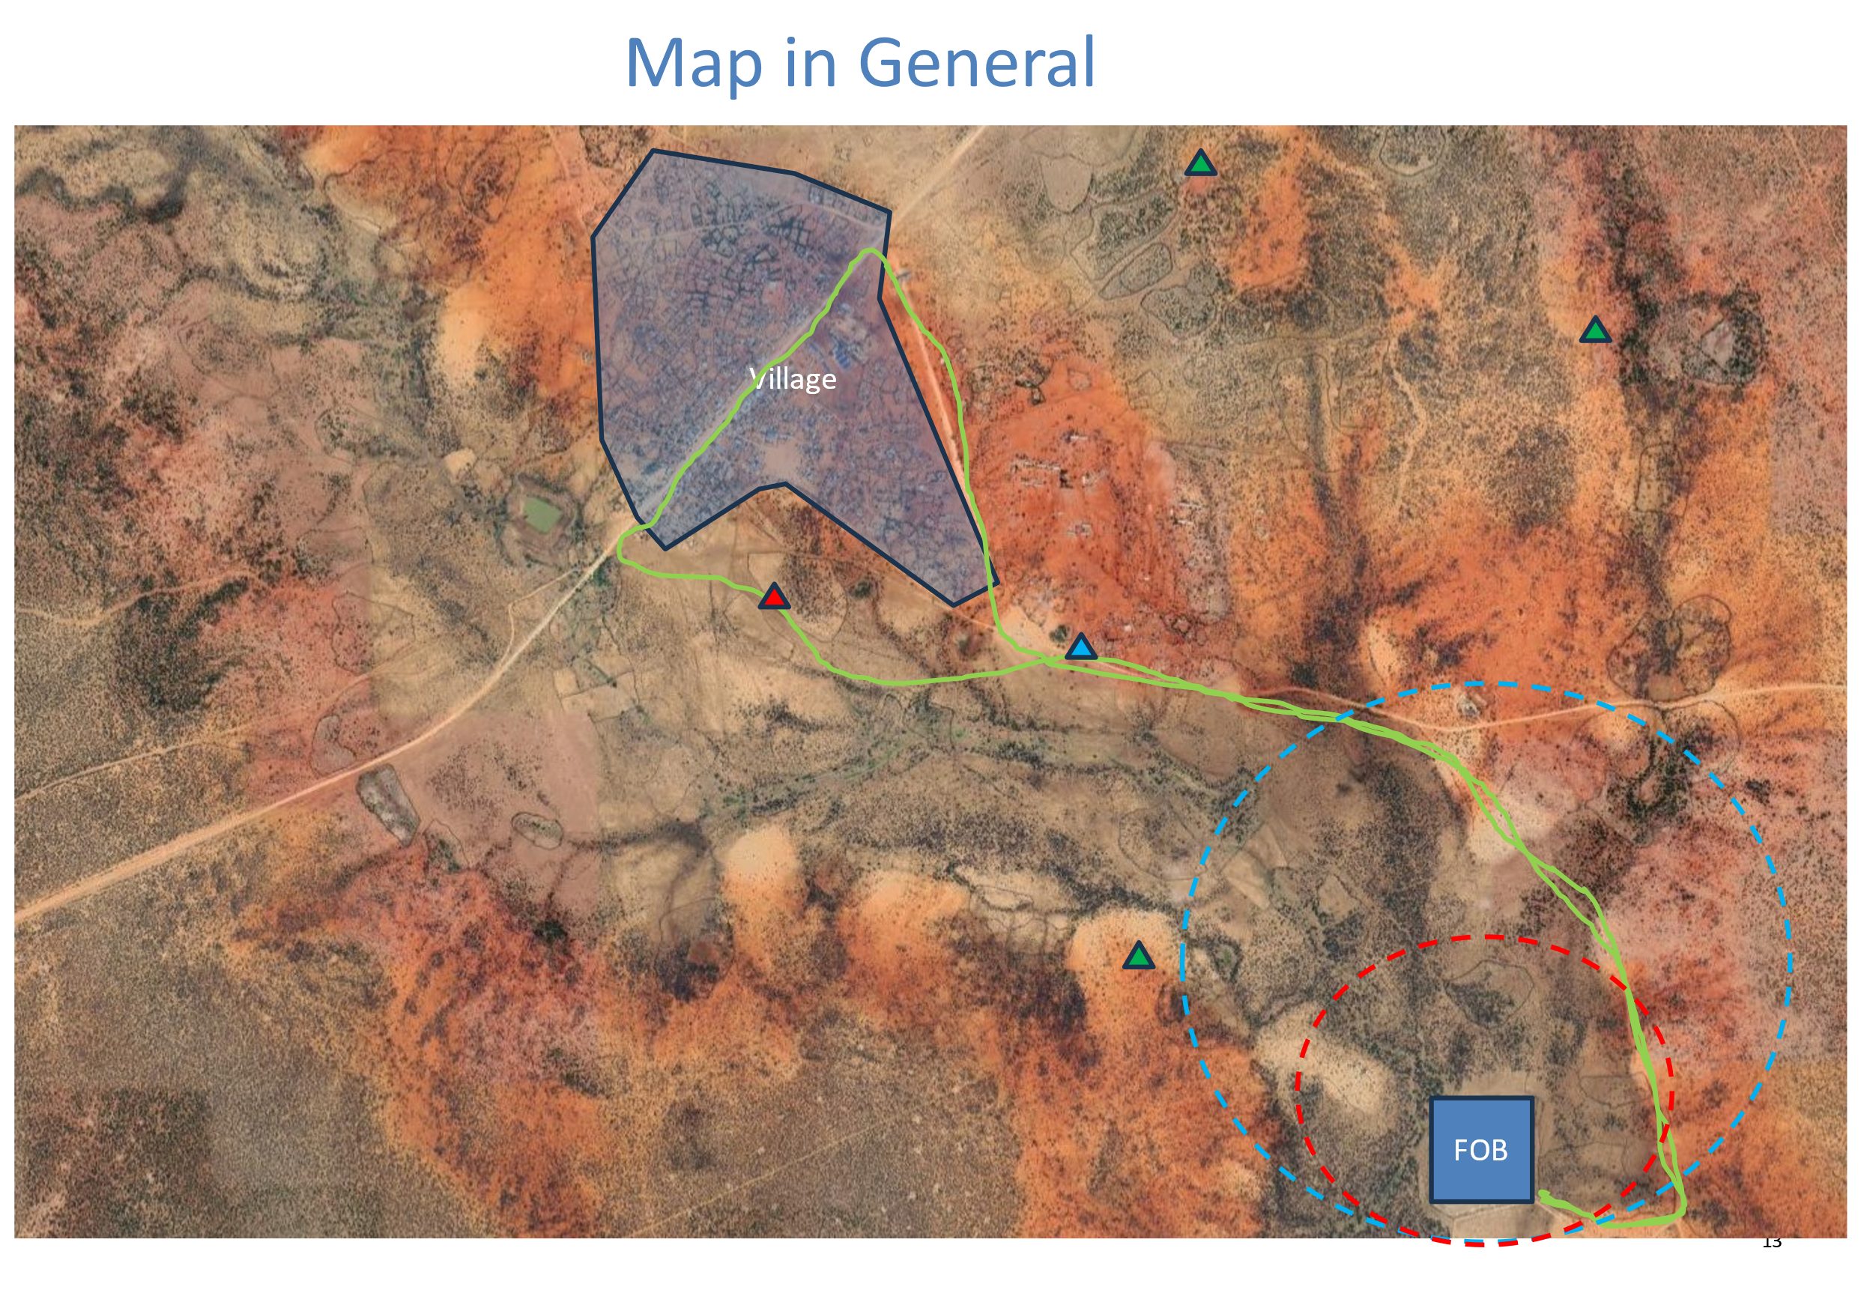
Instructor Guidance – NOT TO BE ISSUED TO STUDENTS
The students should be encouraged to use the correct IED make up and deploy them in the correct manner:
Intent
Who is the target – the students should highlight that the UNMIC are the target and civilians should not be harmed.
Why – the students should extract from the scenario.
Capability
What – the insurgents have all types of IED but the limited access to resources and movement in the vicinity of the FOB. This should steer the students toward the use of Victim Operated or Command Wire Operated IED emplaced at night. Main charge will be dependant on whether the patrol is mounted or dismounted.
Opportunity.
Where – the student must identify to the likely terrain to conduct an attack. These include the slow down points of the route, the areas where the FOB cannot observe, the situational VP created by the stop off location. The use of high features as firing points. Student should highlight that the observed area by the FOB by night should not be a VA/VP. Minimal collateral damage should be considered.
When – If the students highlight the field of view from the FOB is reduced at night then they must consider IED emplacement in darkness and the challenges this creates vs IED emplacement in the heat of the day.

Possible IED Emplacement.
1 – Slow down point. Possible Command IED, not the best view from firing points and close to village.
2 – Channelled area. Possible VO IED or Command IED, close to village.
3 – Situational VP. Possible VO IED or Command IED with good firing points.
4 – Road junction. Possible Command IED not observed at night with good firing points.
5 – Channelled area and not observed at night,
6 – Slow down point. Possible VO IED or Command IED. Not observed during day or night. Not the best view from firing points.
Note: Other IED locations can consider. Students are only limited by their imagination.
4
2
1
5
3
6

